Describe some similarities between a Poisson Distribution and an Exponential Distribution. What are some of the key differences between a Poisson Distribution and an Exponential Distribution?

**Reflection Journal 23/11/2017**

Similarities between Poisson Distribution and an Exponential Distribution:

* Both distributions are illustrated by its own probability density function (PDF).
* A mean and variance value can be derived from both types of distributions.
* Both types of distribution can be in the form of graphical representation.
* They both use similar symbols in their respective formulas such as λ and base e.
* For both Poisson and Exponential distribution, they are both used to evaluate random variables.
* Events occur continuously and independently.

Differences between Poisson Distribution and an Exponential Distribution:

* The Poisson distribution models many occurrences in a fixed amount of time. This means it is a discrete distribution. The Exponential Distribution models the waiting time between consecutive occurrences. This means it is a continuous distribution.
* Exponential Distribution examples:
* the time until the first school bell
* the time from now until the next world cup
* the time interval between two goals in a football match
* Poisson Distribution examples:
* the number of car accidents in a year
* the number of failure of a machine in one month
* The formulas used are different:
* For a Poisson distribution:

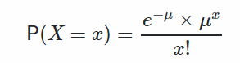

where μ is the mean number of occurrences.

* For an Exponential distribution:

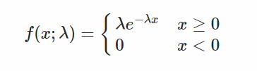

where λ is the rate parameter.

* With reference to the formulas, Poisson is a discrete distribution where its’ sample values are always integers which makes no sense to use it for inter-arrival time. As for Exponential distribution, it is a probability distribution that describes the time between events in a Poisson process which is why it uses inter-arrival time.

Thank You and Have a Nice Day! :)